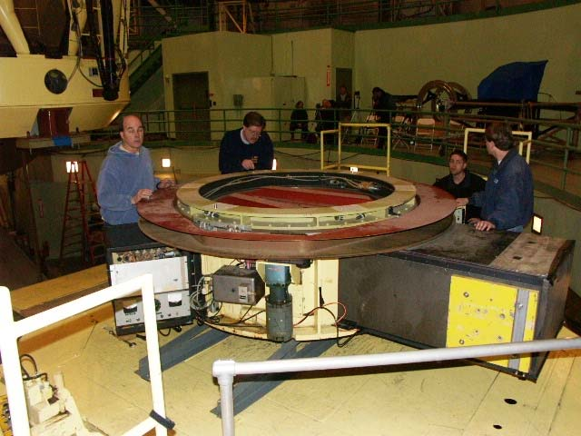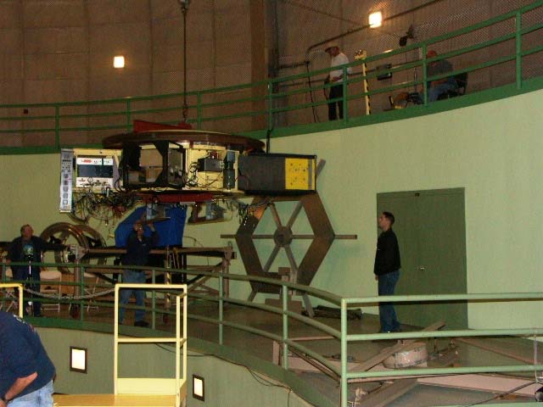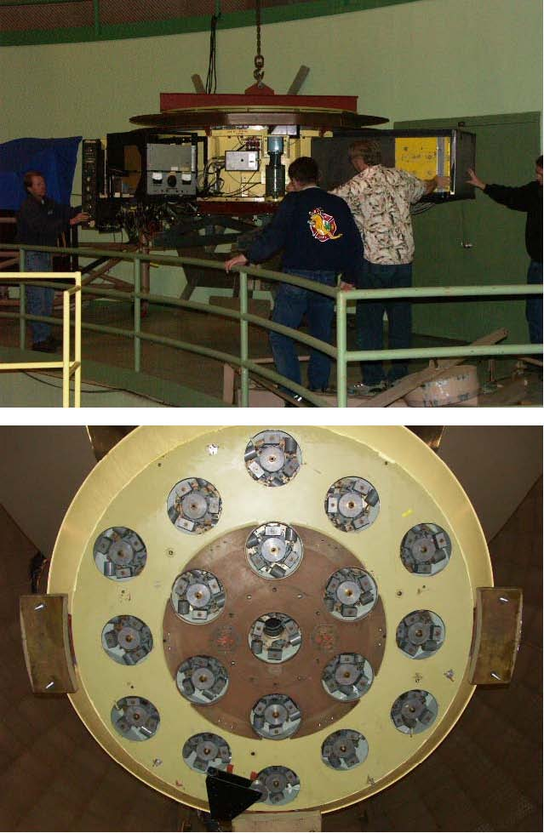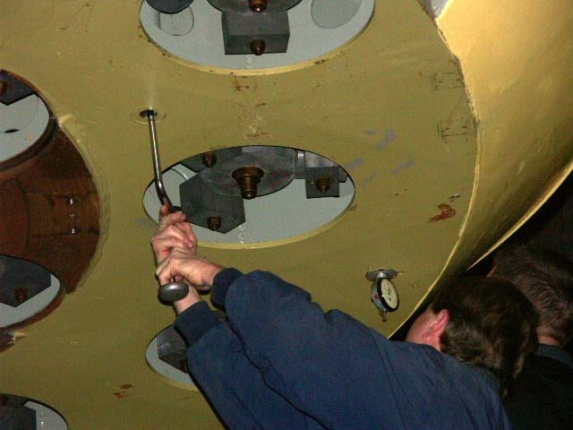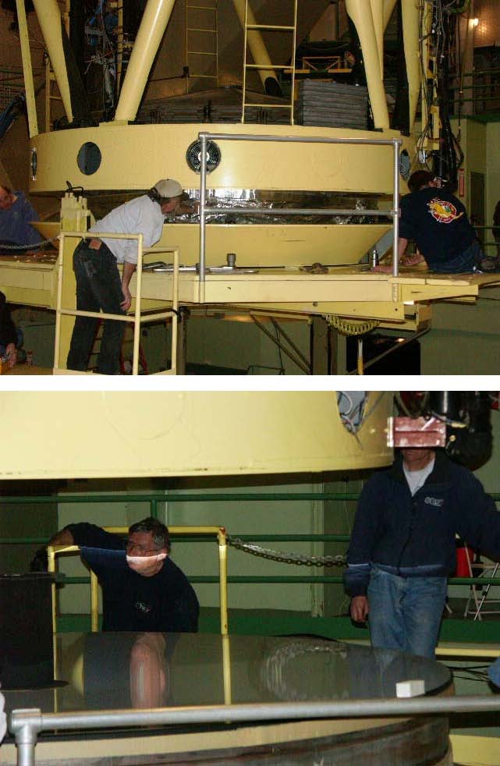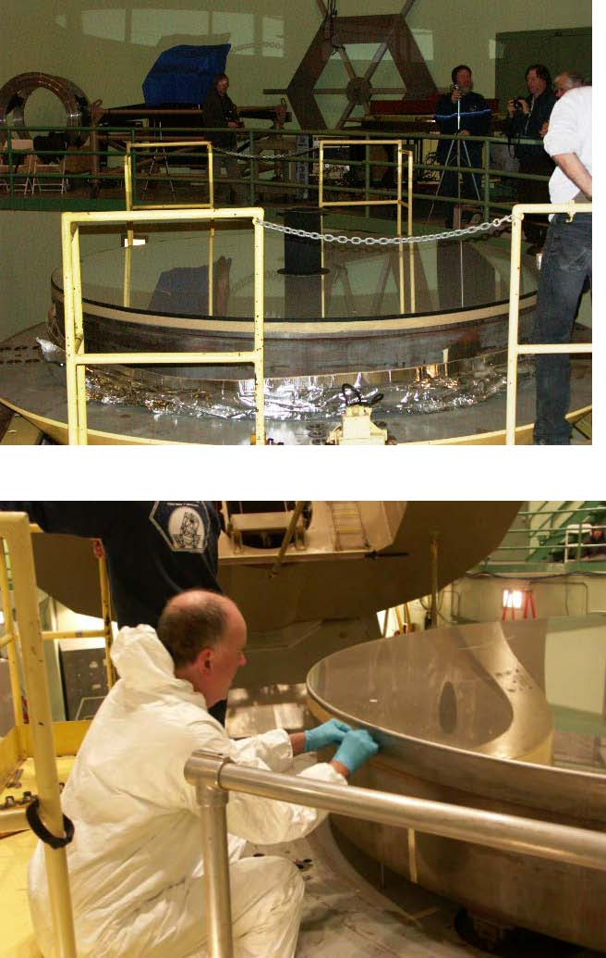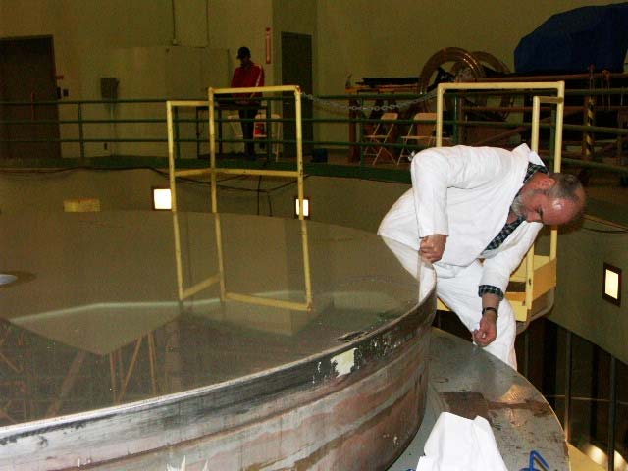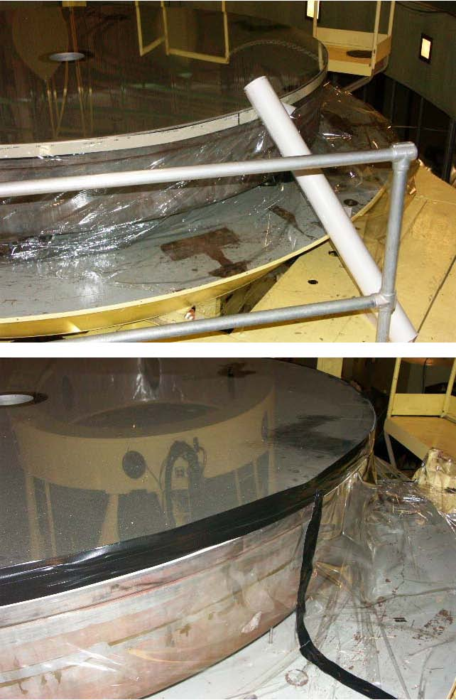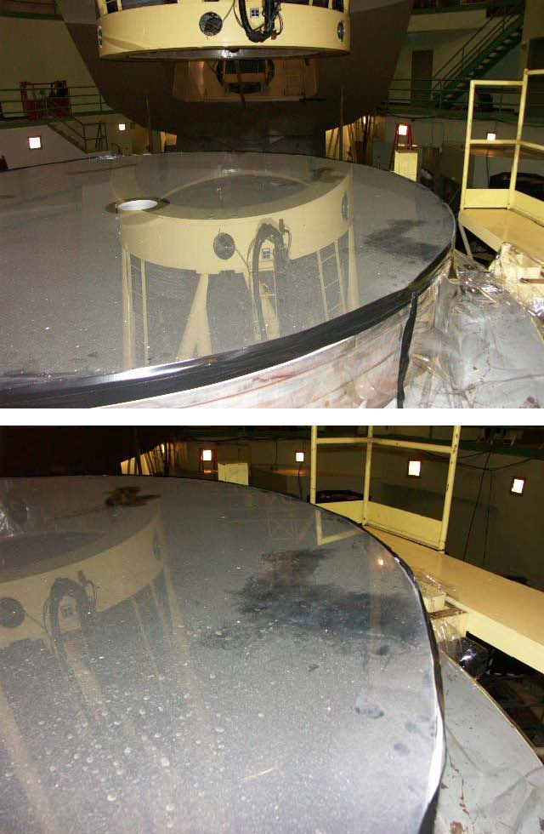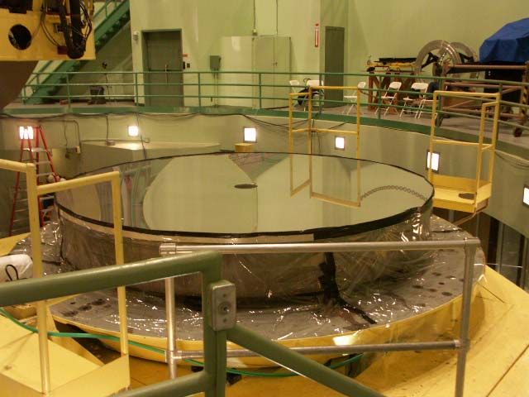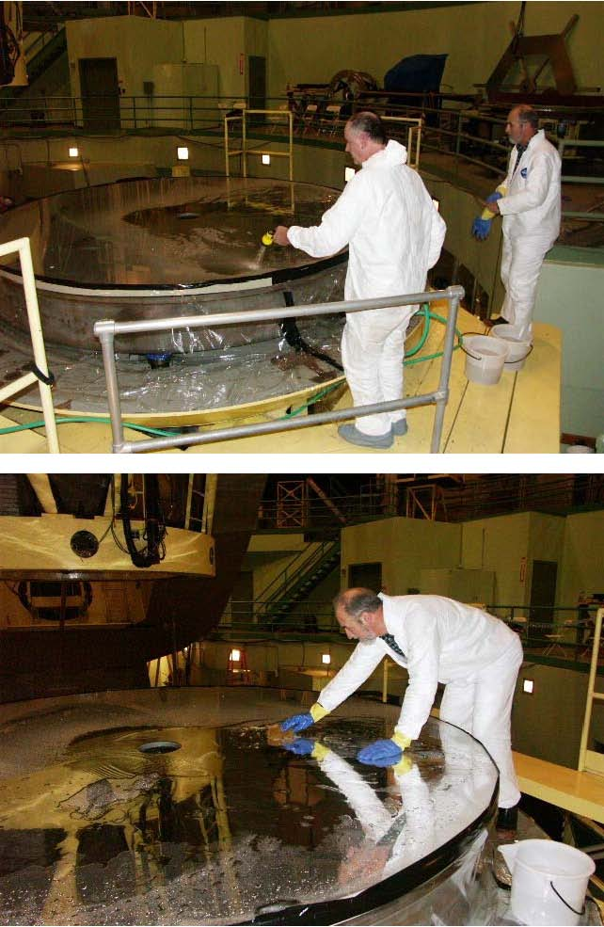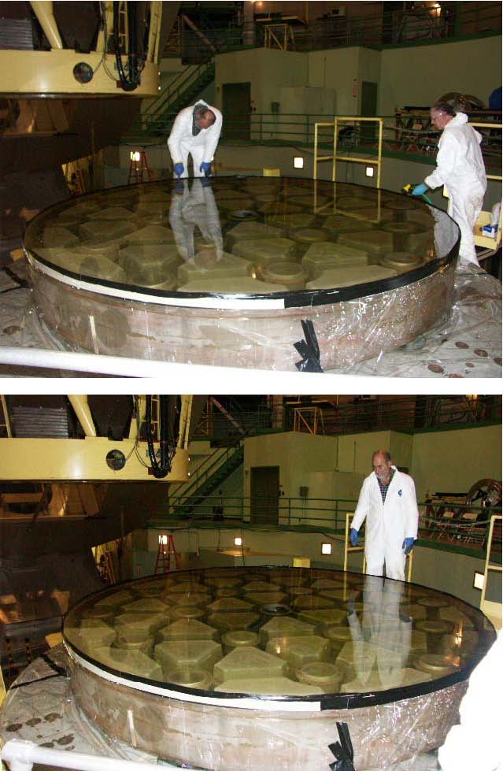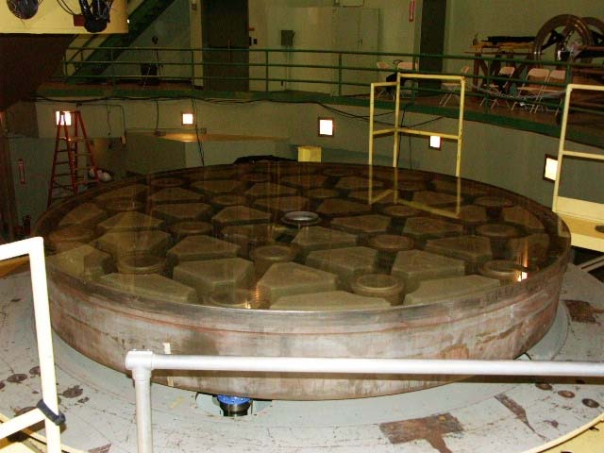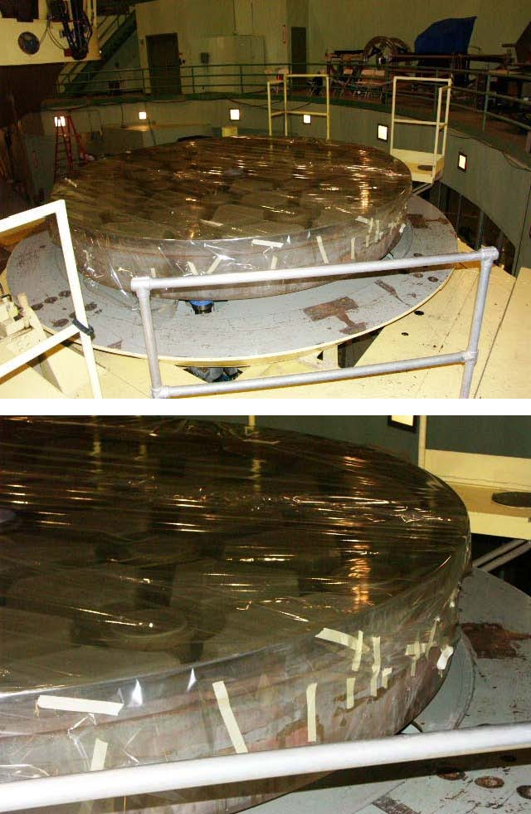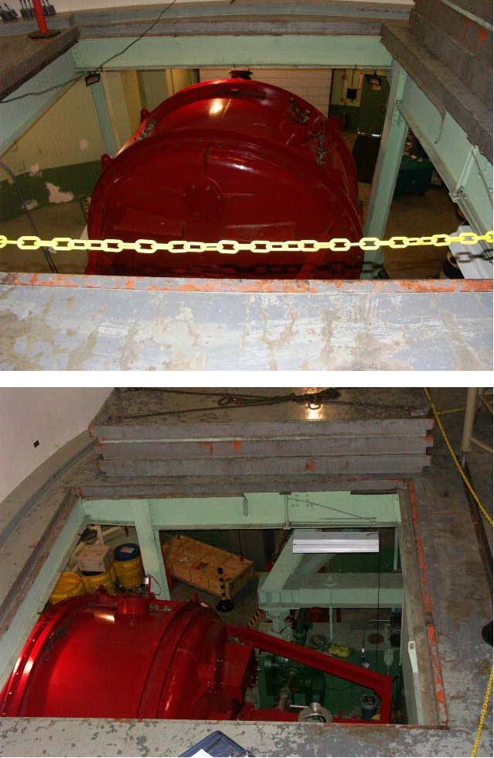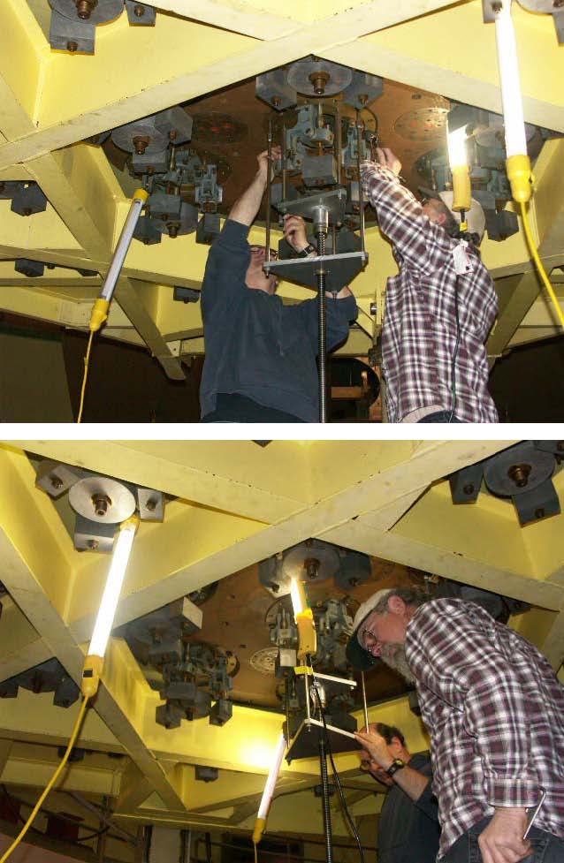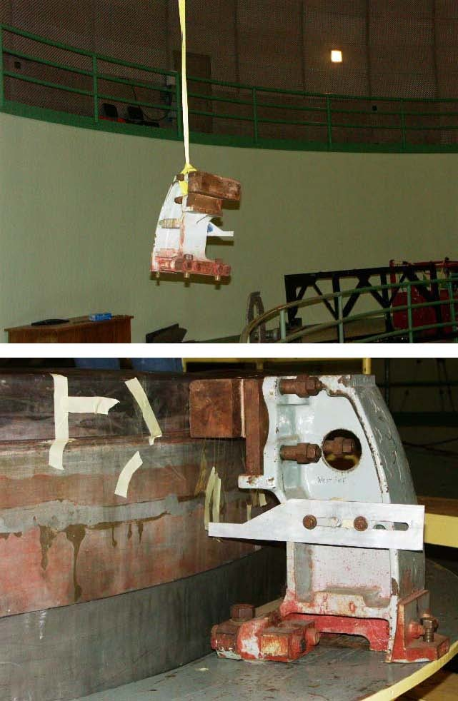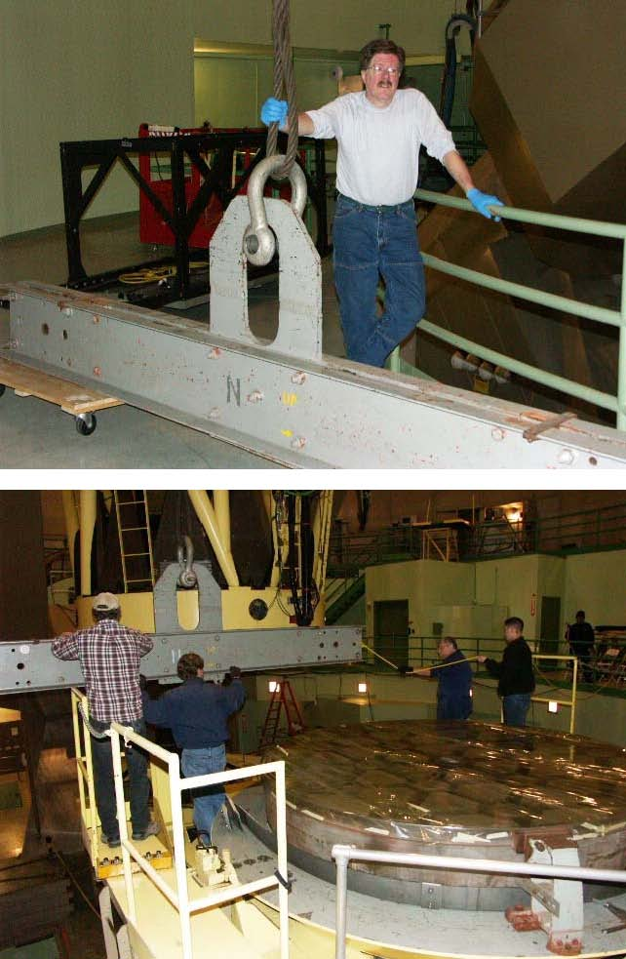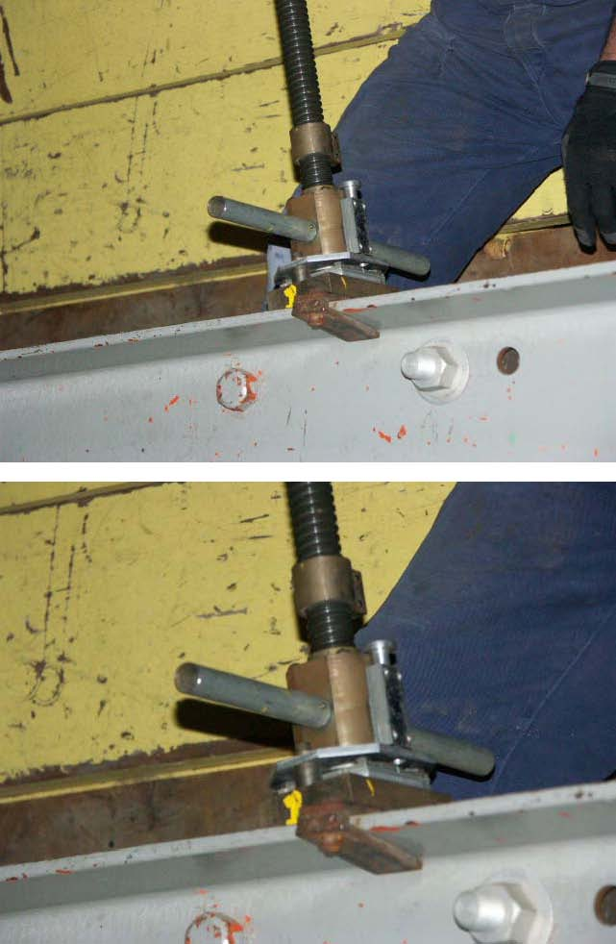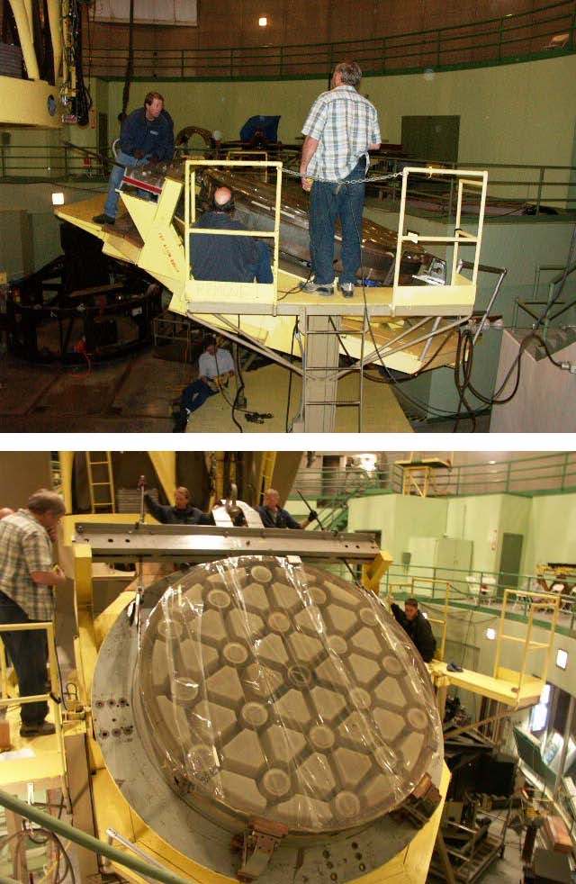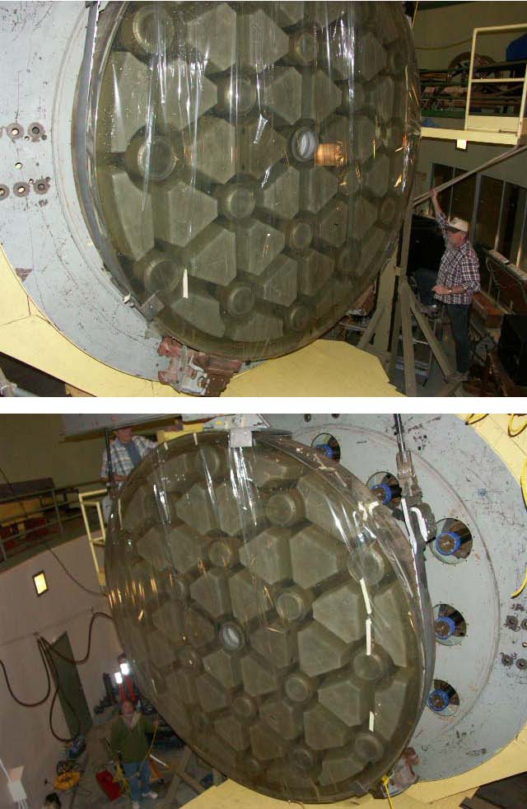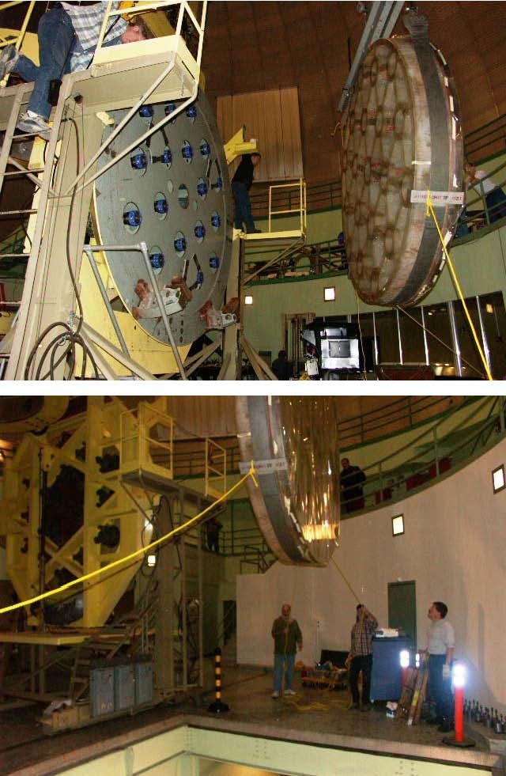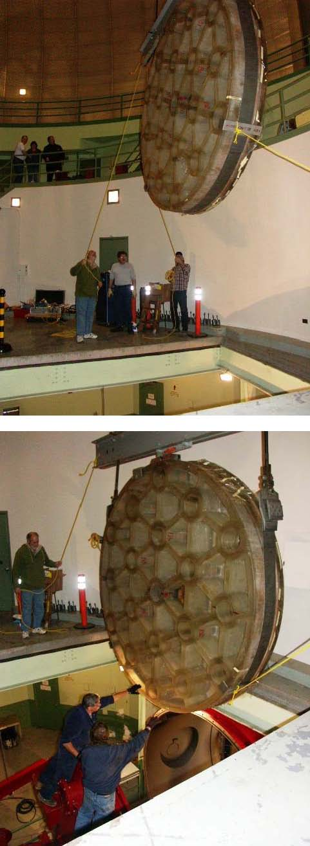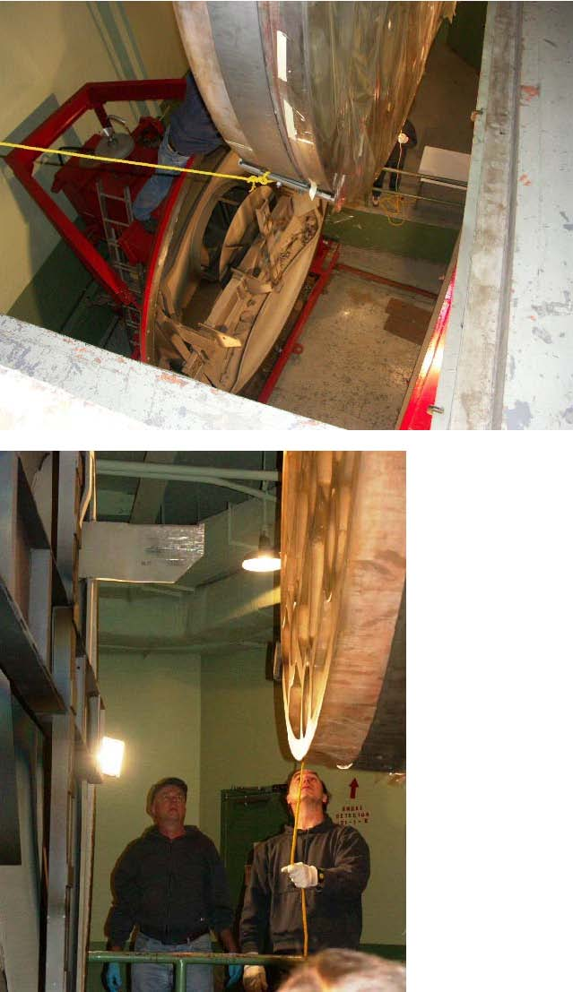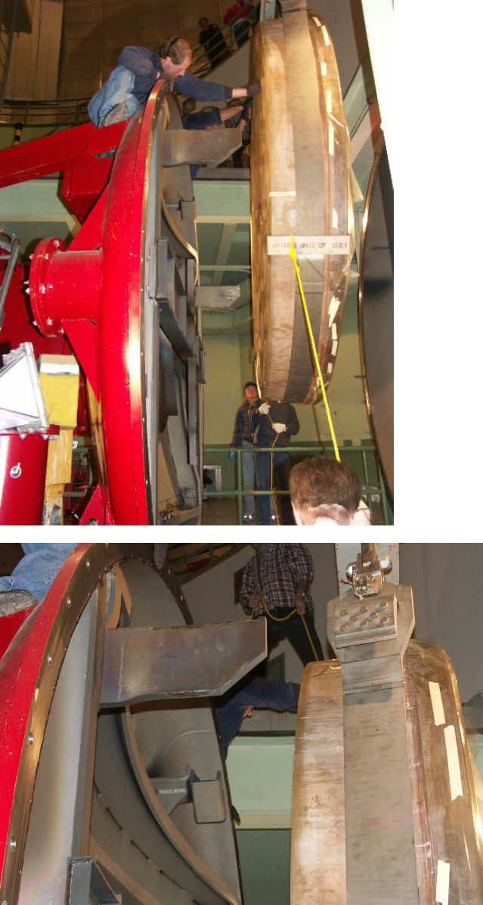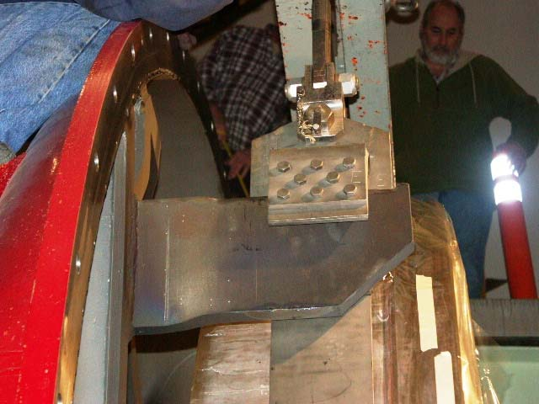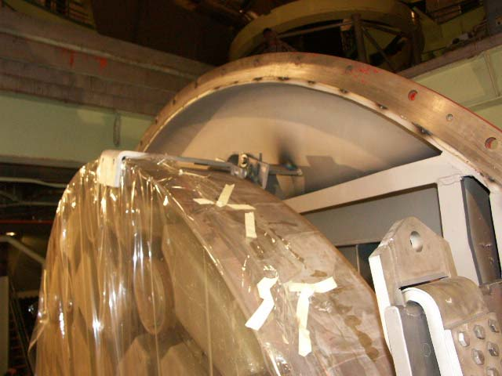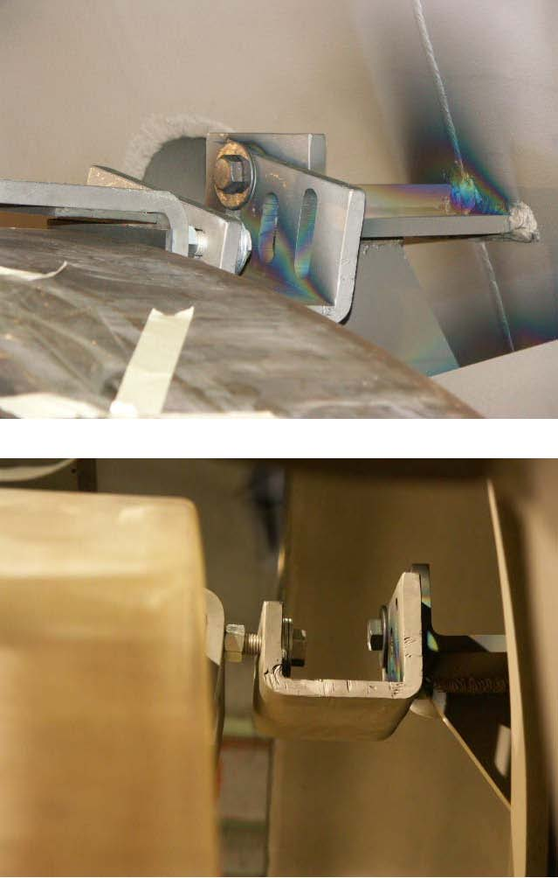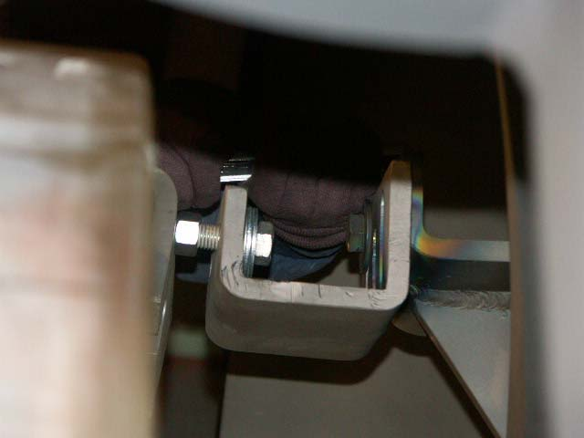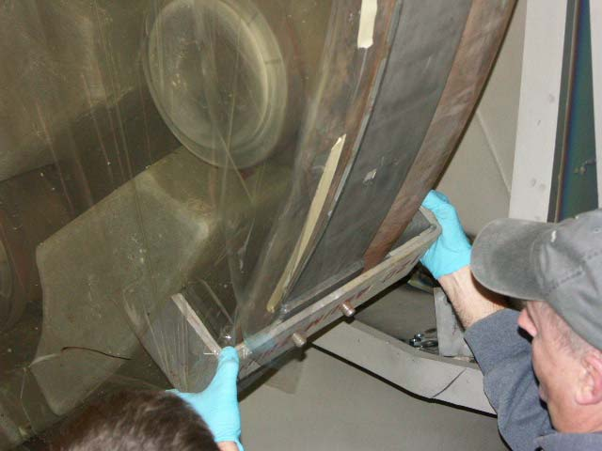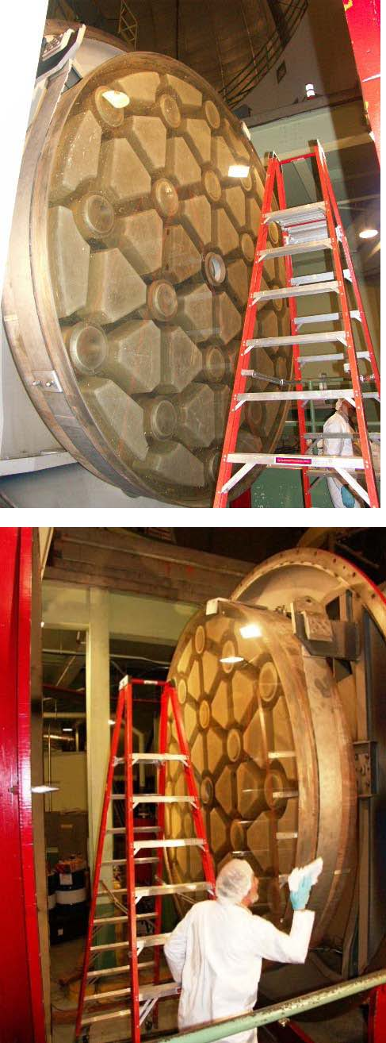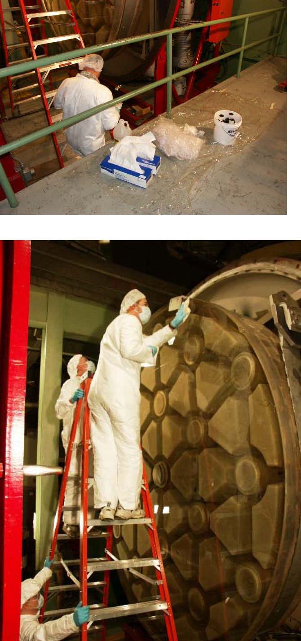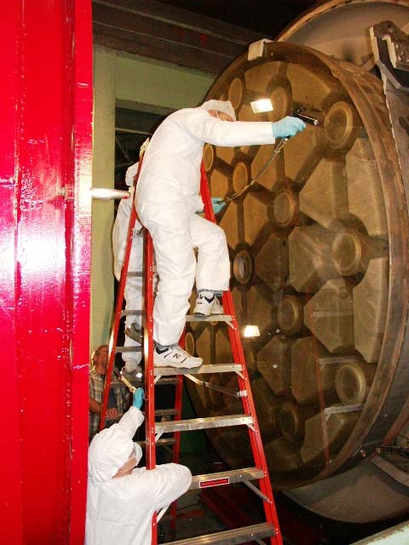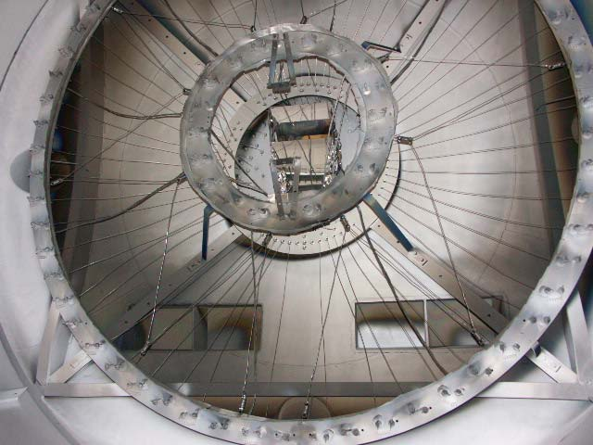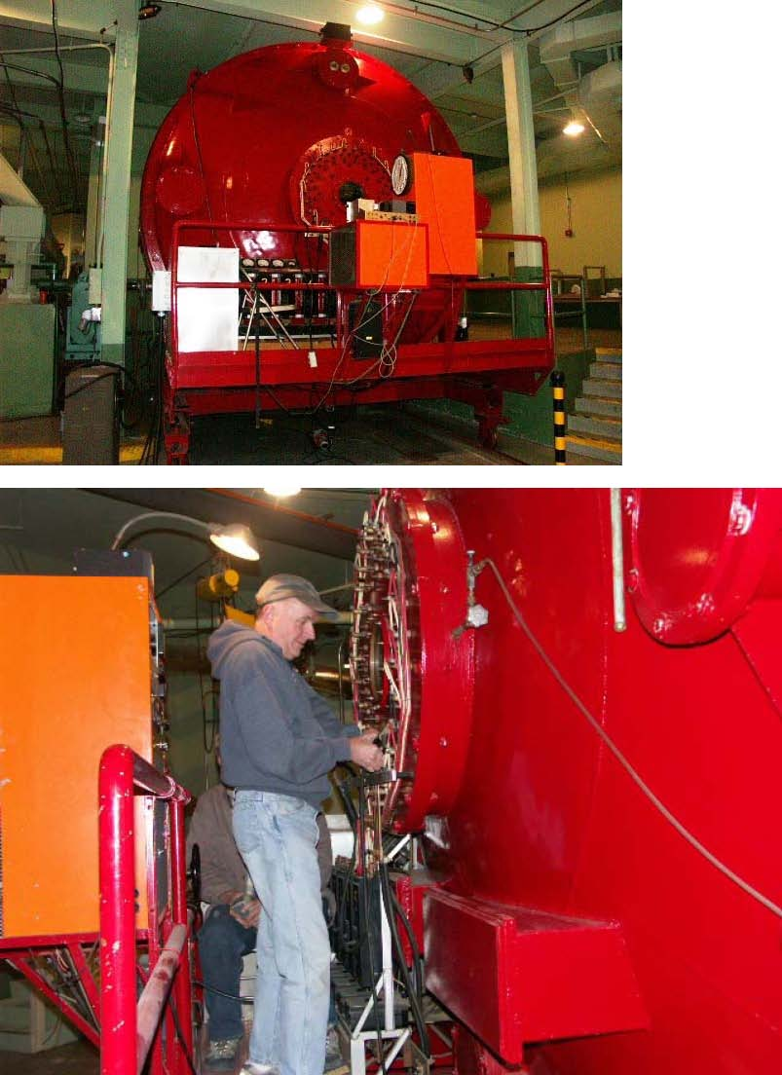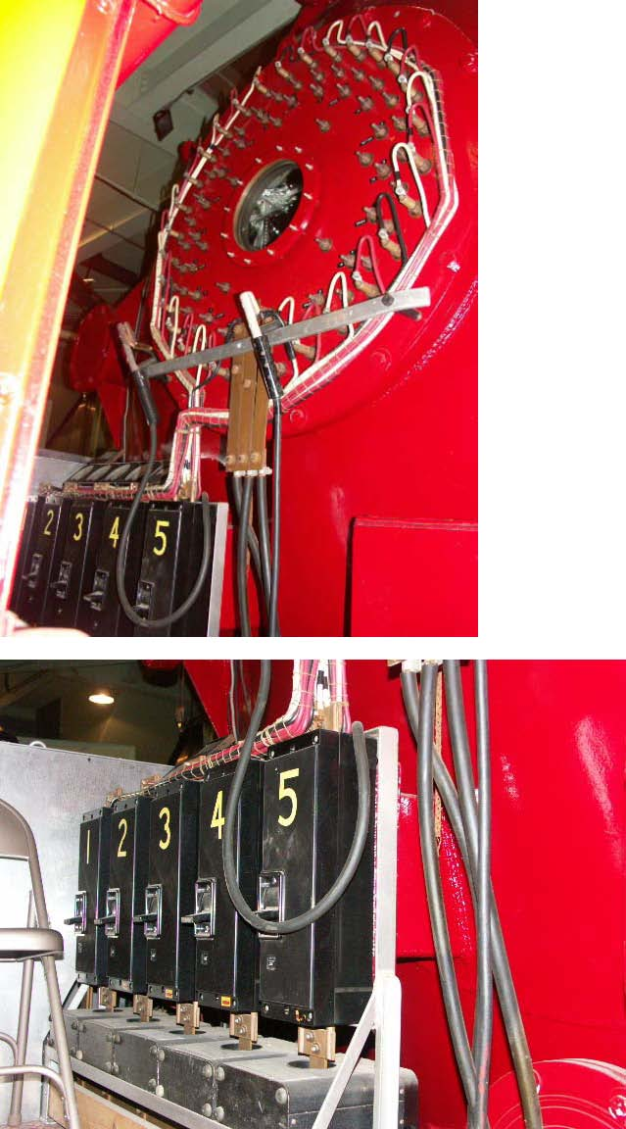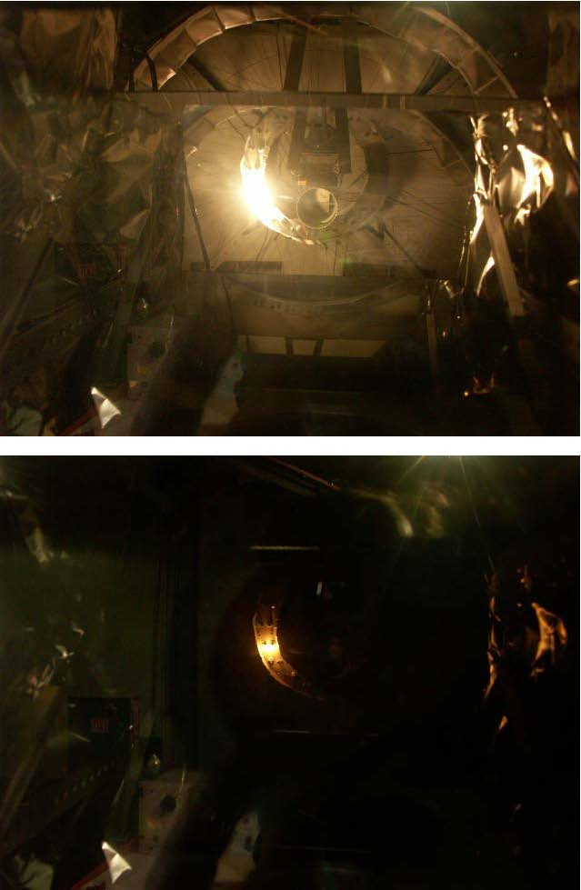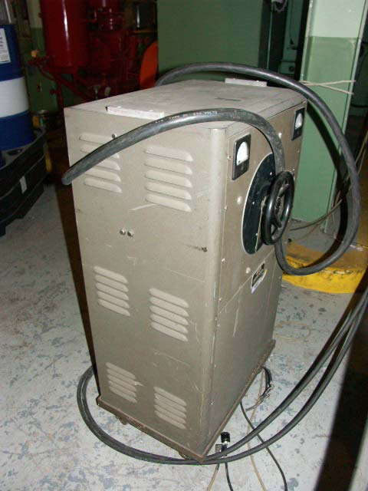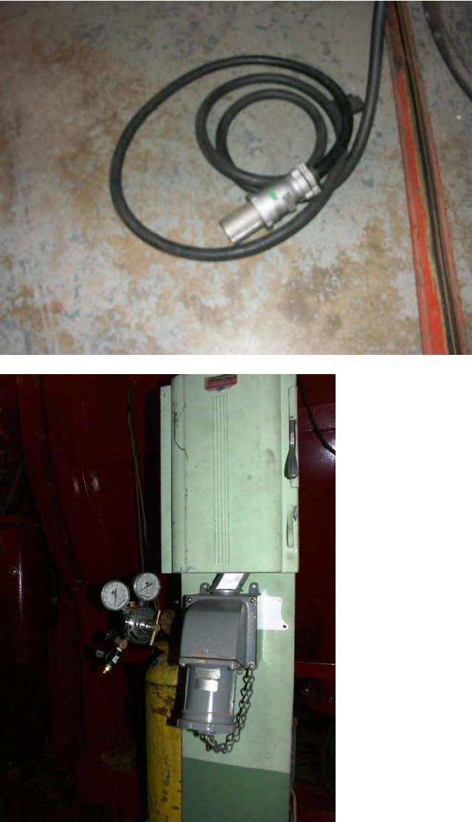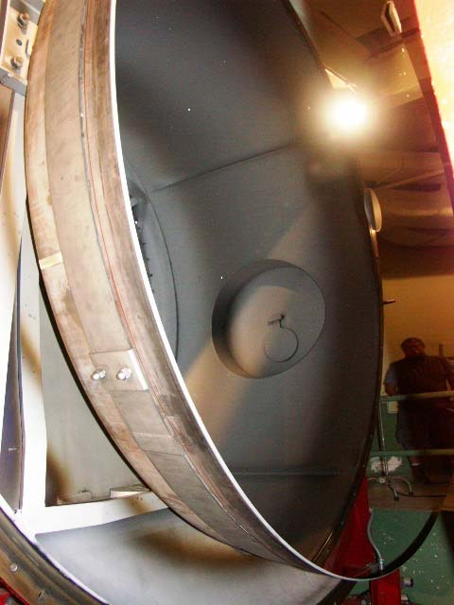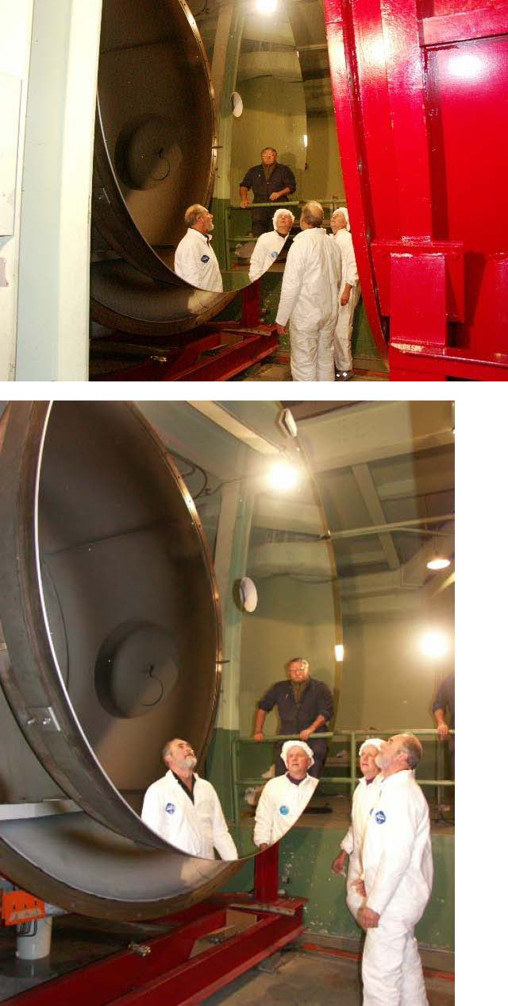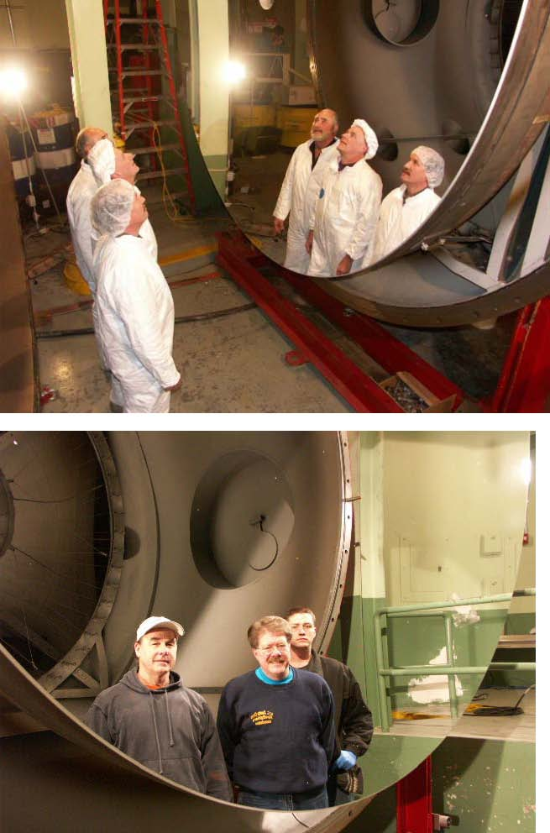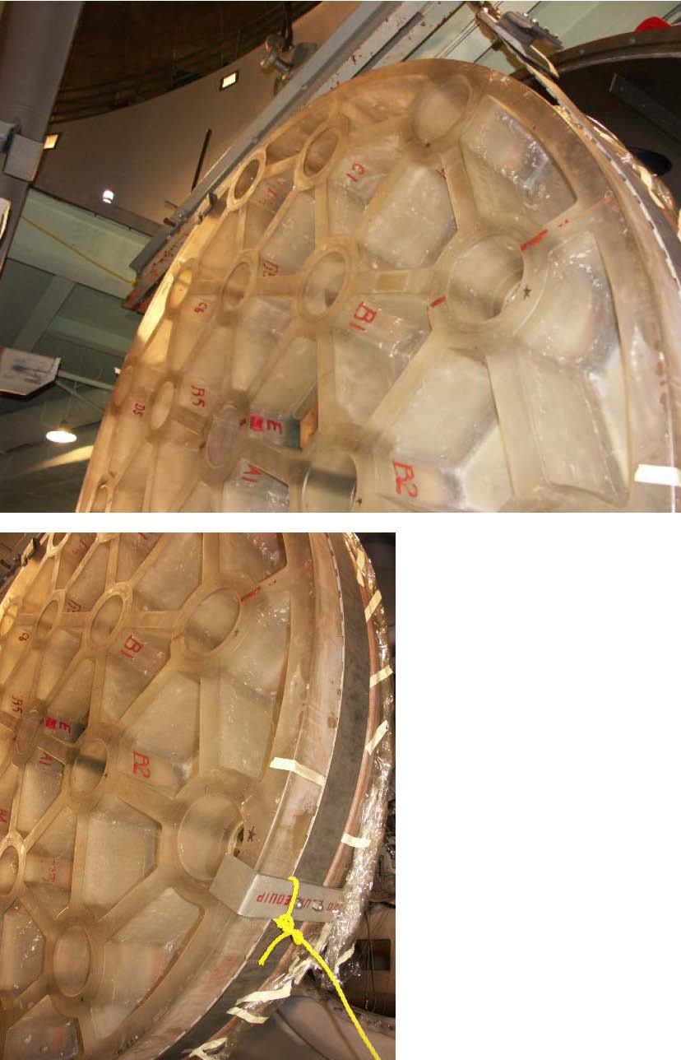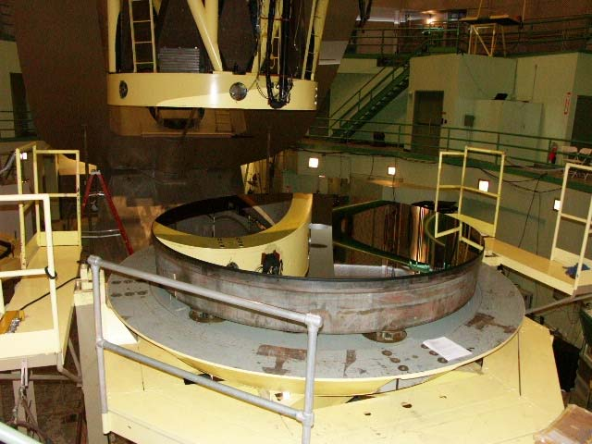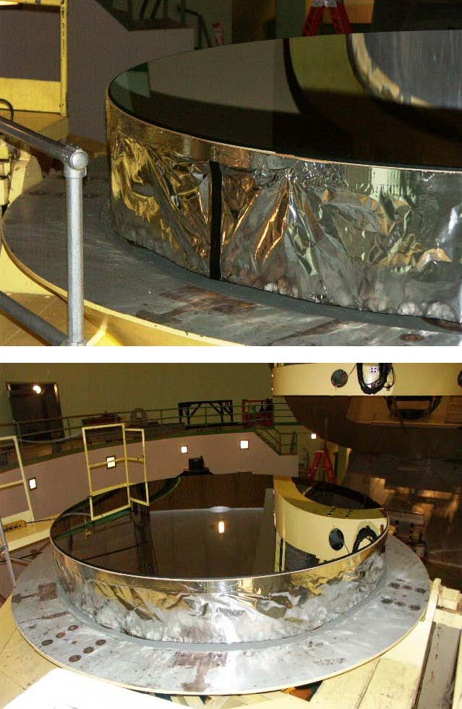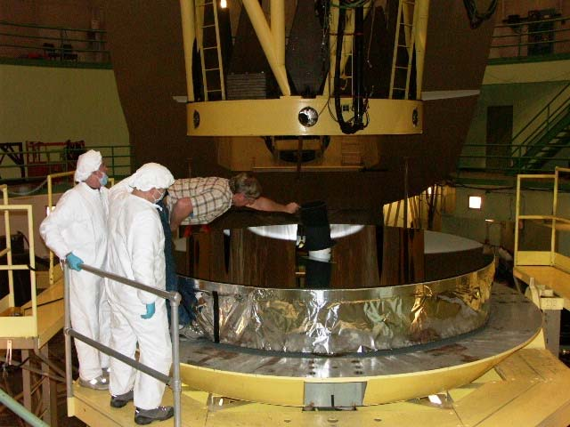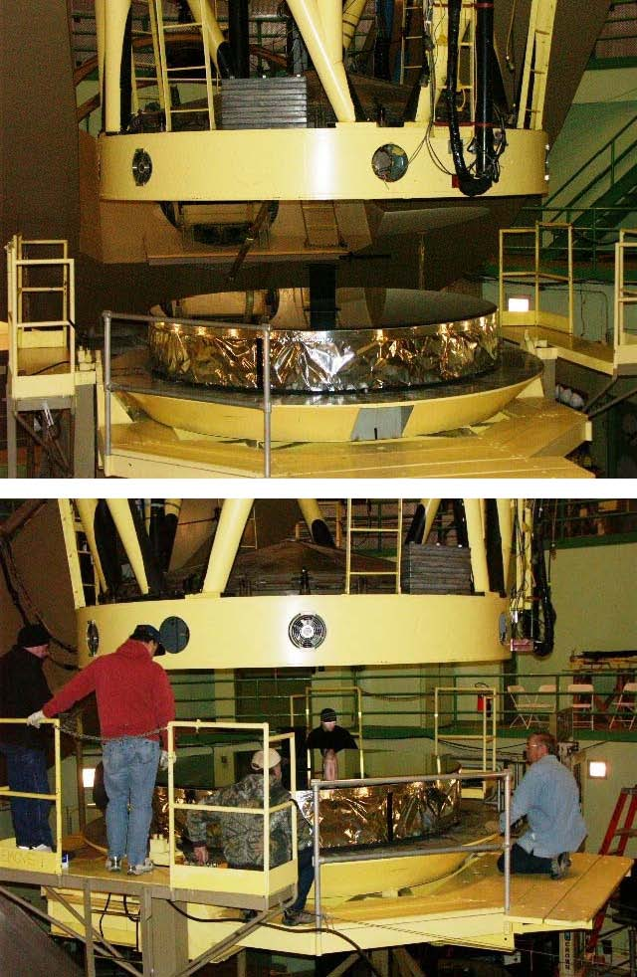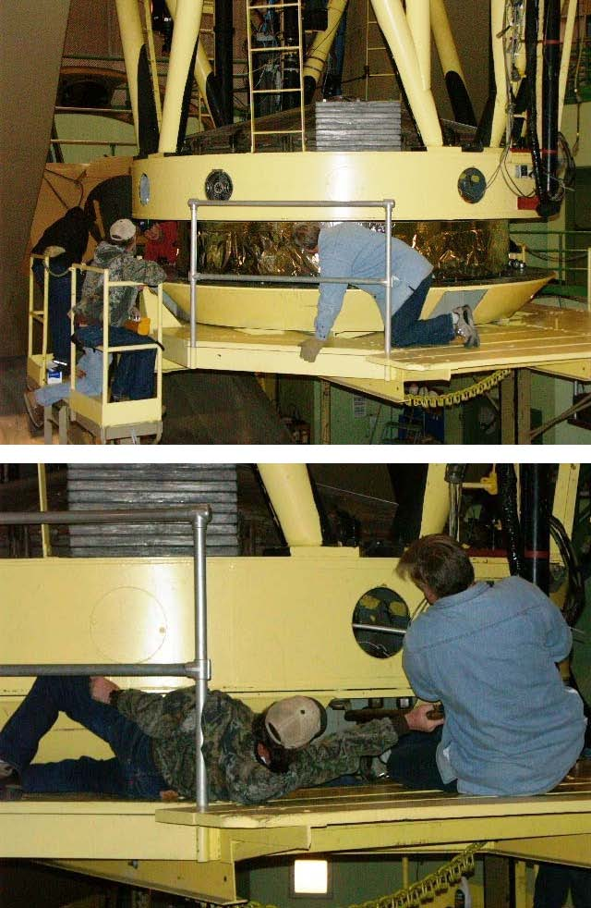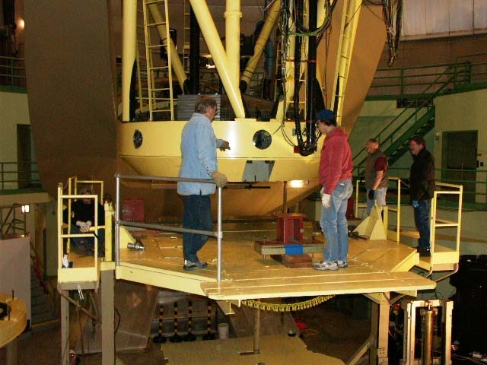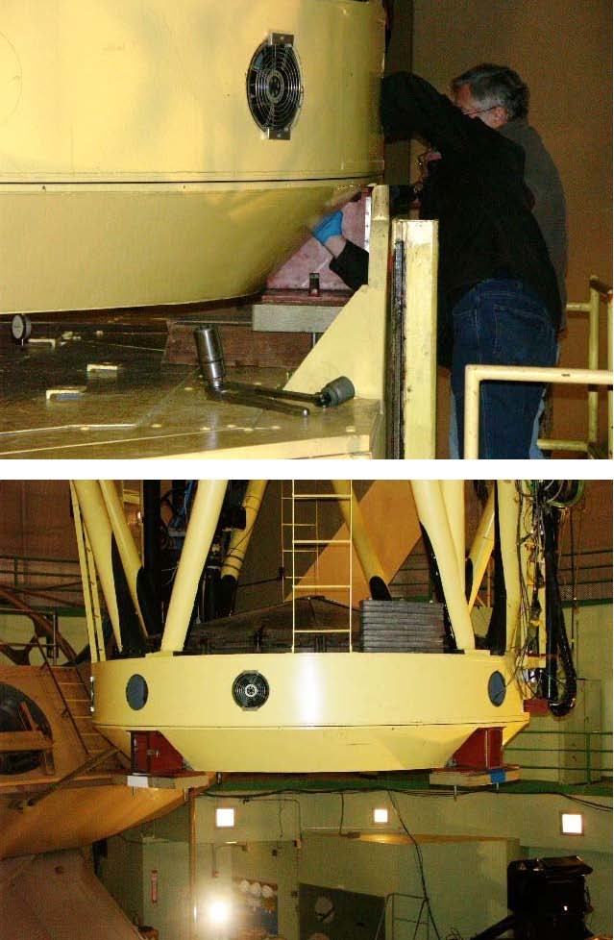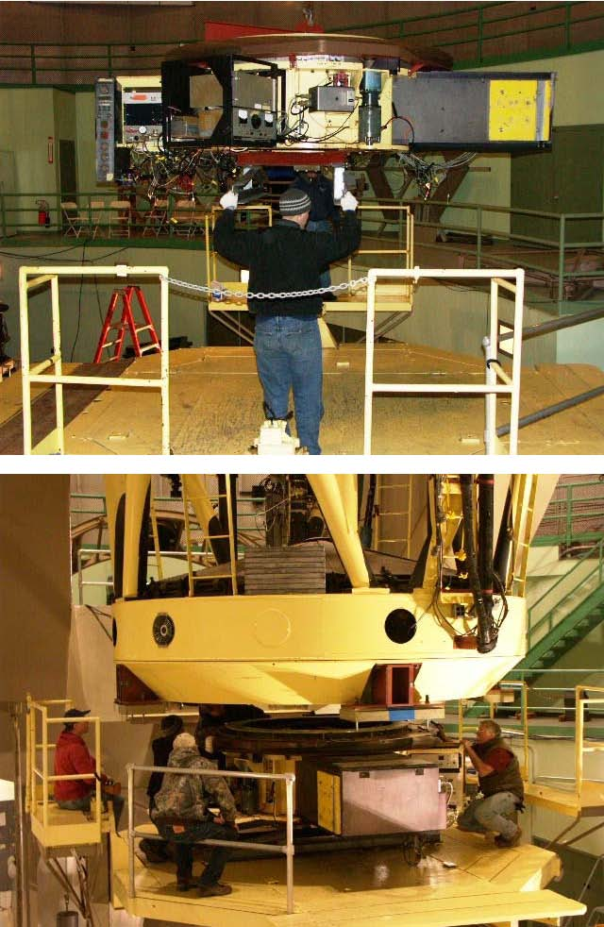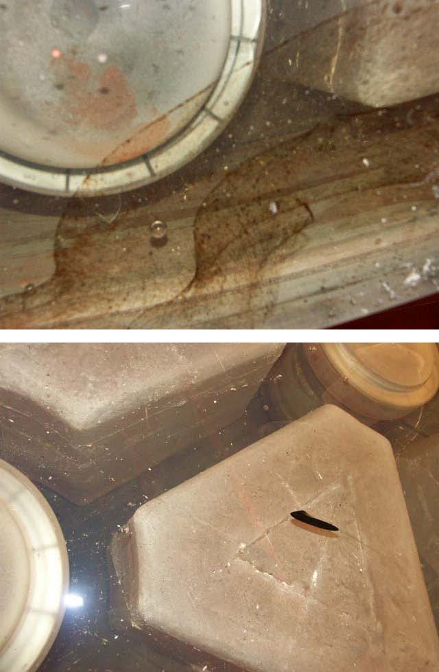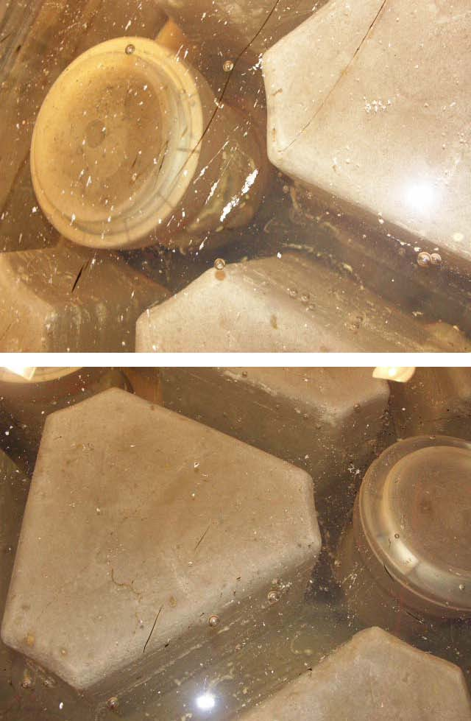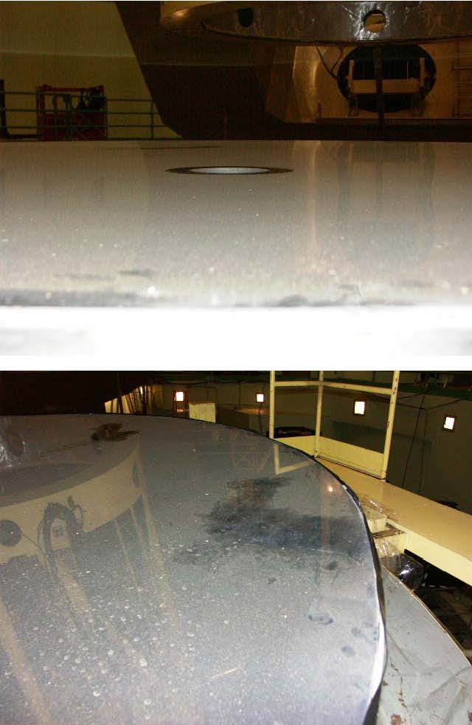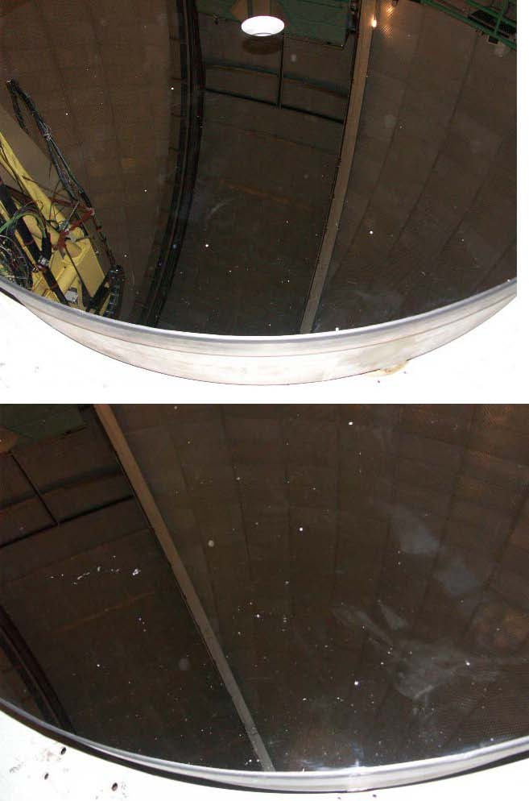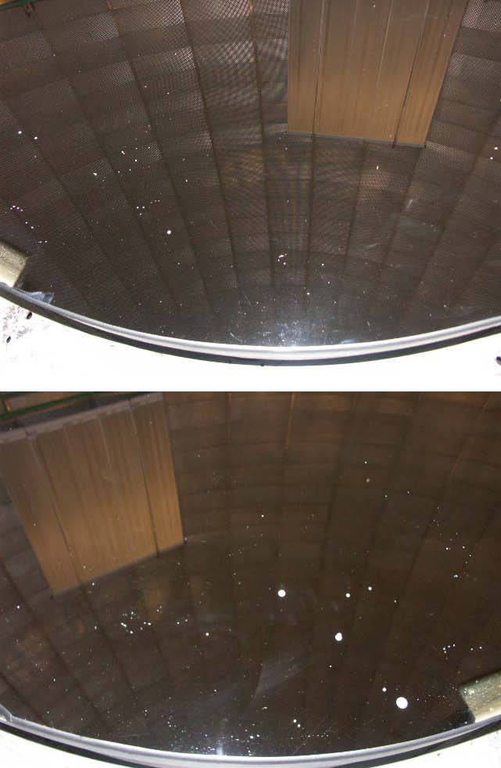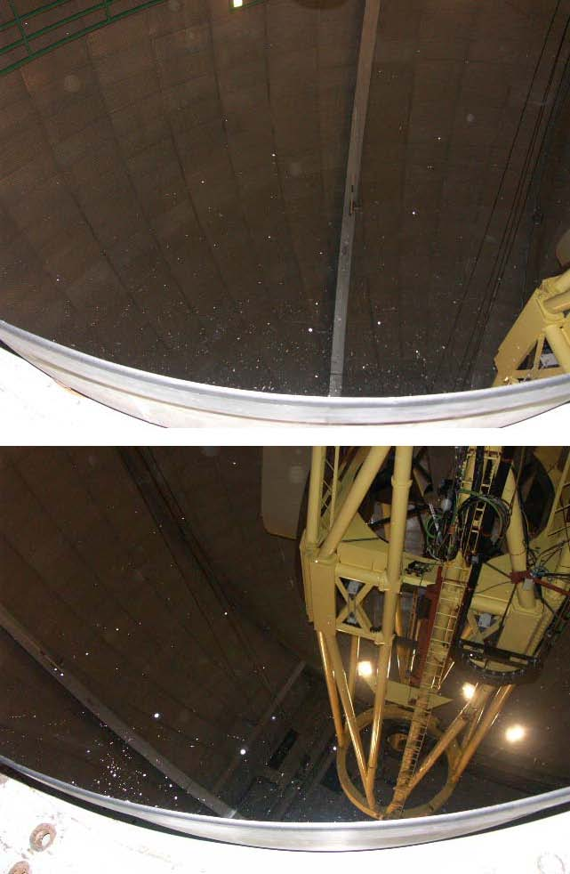
February 13 – 16, 2006
Day 1
While the mechanical team was removing the mirror we prepared a workspace on the mezzanine by laying down a sheet of plastic in an out-of the way space. We mixed up chemicals and set them on the plastic sheet.
We mixed:
1) HCl and H20 in a 1:1 ratio (1 gallon each mixed in a 5-gallon bucket)
2) Green River (HCl and H20 in a 1:1 ratio plus 500g cupric sulphate)
3) KOH ½ lb estimated and 1 gallon H20
4) CaCO3 (calcium carbonate) transferred from glass container to plastic to reduce risk of
damage to mirror if it were to be dropped
5) Two separate buckets of Orvus/water with natural sponges
Prior to our arrival, the telescope crew had prepared 7 giant Q-tips by tying cloth or cotton around the end of 2’ long pieces of PVC pipe.
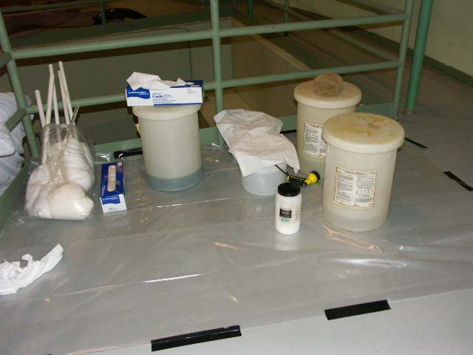
The “hub” or instrument mount was removed and set aside to gain access to the mirror.
The mirror was removed and set on the large moveable platform and the platform brought near the mezzanine.
We next removed the old foil, tape and cardboard from around the circumference of the mirror, cleaning off the tape residue with acetone.
We then used a layer of masking tape and a layer of double-sided tape to attach a 3’ or 4’ wide skirt of vinyl to the mirror, draping it down to protect the painted surfaces and the people working below from the fluids we were preparing to use. We had to put the vinyl on in several sections, and we were careful to overlap the sections with more vinyl and to seal the joints with duct tape.
On top of the vinyl we made a ½” dam around the circumference by folding a piece of 2” duct tape over on itself and sticking the unfolded portion down on the vinyl. The result was designed to keep the fluids on the mirror, flowing into the central hole, and not off the edges and onto surfaces and people below. The central hole was connected to a drain line that was held in place by an inflatable tube (not shown)…it drained to the darkroom sink. For future re-coats we recommend a pre-formed dam, possibly of plastic.
Before doing any cleaning or stripping we used the reflectometer to measure the initial state of the mirror. Note that it was a relative value, as compared to an aluminum mirror kept in a box with the reflectometer, and not an absolute measurement. Dave set the instrument down on the mirror at each of four places (N-W-S-E) while Brian followed him around carrying the indicator, tethered together by the electrical wires. Bill wrote down the values Brian called out. The northern measurement point was repeated for a sanity check and found to be within 1%. The measurements were taken twice: once with a blue filter and once with a red. No photos.
The mirror was then rinsed towards the center hole, washed with Orvus/water using natural sponges and rinsed again with tap water from the spray hose.
After washing we dried just the same four locations for the reflectometer. We repeated the measurements and found that just washing it increased the reflectivity from 73% to 83%. Since we were going to strip it we didn’t worry about the water drying in spots.
Next we stripped the aluminum off by swabbing it with the giant Q-tips dipped in Green River. It came off easily, revealing the structure of the mirror below.
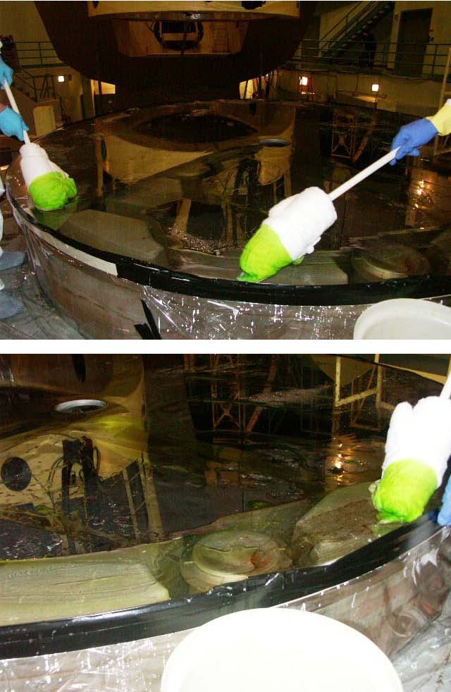
When it was all stripped we rinsed the Green River down the drain in the central hole. A second hose might have made it easier to “herd” the fluid down the drain.
We then went right into the cleaning process by swabbing the surface with KOH / H2O using fresh Q-Tips. Bill then sprinkled copious amounts of CaCO3 (calcium carbonate) on the wet surface and we used Kaydrys dipped in the KOH / H2O solution to make “toothpaste” of the CaCO3. We rubbed the surface all over and then rinsed it down the center hole. Again, a second hose might have made it easier to “herd” the fluid down the drain.
We looked for sheeting of the fluid as it washed away, and when spots were found to not be wetting we re-applied CaCO3. The perimeter never quite sheeted.
The last chemical we put on was the HCl / H2O solution, to neutralize the KOH. We let it sit for a minute and then washed it away. A step that we inadvertently left off was rinsing again with copious amounts of de-ionized water, which we had available but forgot to use.
We dried the water off with Kaydrys, being careful not to let the spots air-dry. We also were careful not to touch the surface with our gloved hands. To reach the middle we used a wad of Kaydrys under the hand that supported our weight while we dried with Kaydrys in our other hand.
Finally, we carefully removed the vinyl barrier and mopped up any fluids that leaked through to the platform.
The last step for the night was to cover the mirror with cellophane, which came on a roll in a 4’ wooden box. We taped it to the edge of the mirror on one side and unrolled it without dragging it on the surface, then taped it down on the other side. This is another area where we suggest improvement…perhaps a giant shower cap made of sail-cloth or some other light material. Something in the center hole would keep it from touching the surface of the mirror.
Day 2
On the second day we moved the mirror to the coating chamber, pumped down, and coated. First the floorboards were removed, exposing the chamber below.
Under the mirror, the process of disconnecting it mechanically was going on.
Meanwhile, the belly-band was carried by several people to the mirror, with the middle of the band at the mirror’s North side. Two giant edge-arcs were hoisted over to the platform and bolted down.
A large I-beam was brought over and layed horizontally on a special extension on the south side of the mirror platform.
Two large jackscrews were fed through the I-beam and attached to the bellyband. The bellyband was supported by wooden blocks and also two extensions on the sides of the edge-arcs. One “earthquake bracket,” just a C-shaped piece of metal, was attached to the I-beam and loosely gripped the mirror, and two more were attached to the belly-band at the sides.
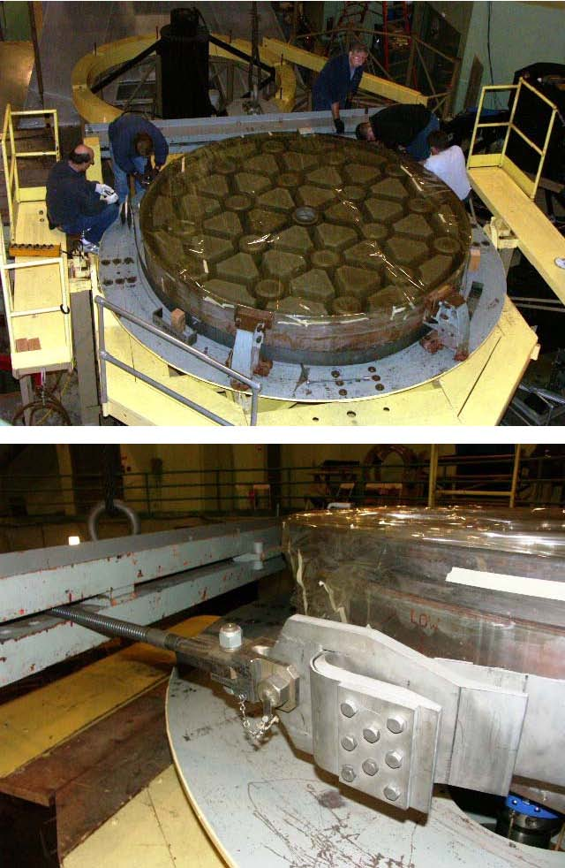
Here is a close-up of the top of the jackscrews, showing the hand-grips for tightening or loosening the bellyband.
Next the platform was tilted so that the edge-arcs took the weight of the mirror.
The crane was raised to just lift the mirror off the edge-arcs, and the platform was driven south to separate it from the mirror.
Using manned ropes to keep the mirror from swinging, the crane brought the mirror over the coating chamber.
The mirror was lowered through the floor and the hook-shaped ends of the belly-band went over two permanent protruding beams in the tank.
The mirror was anchored from moving inside the tank by a custom connection between the “earthquake clamp” on the mirror at the top.
Another anchor was made by removing an “earthquake clamp” from one side and using the bolt on the belly-band to secure it to a fixed bracket in the tank.
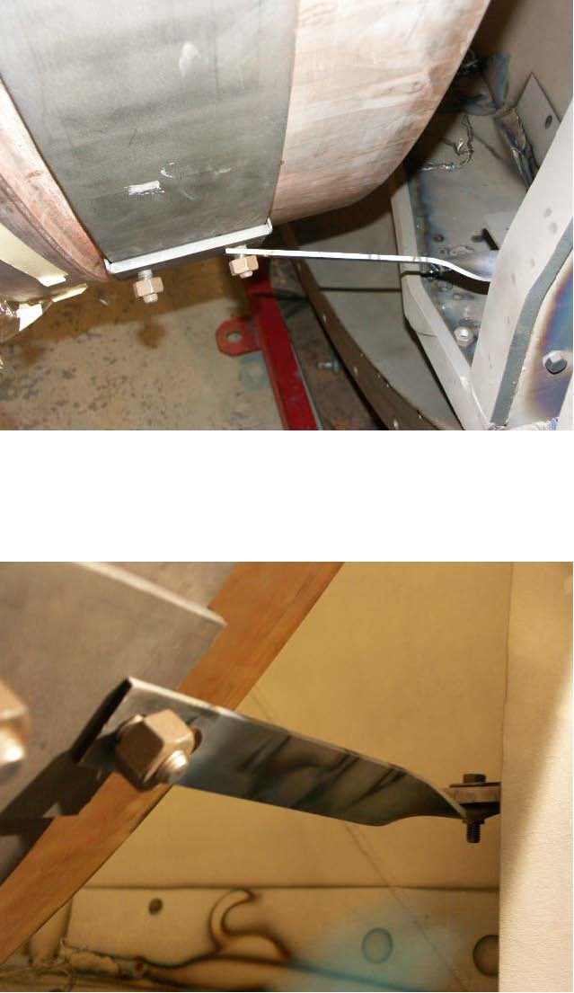
Once it was anchored, the cellophane was removed and the tape residue wiped off with acetone.
Then it was given a final wipe with 2-propanol soaking cloth towels that had been repeatedly washed to remove lint. A second, dry towel was used to wipe up the propanol before it had a chance to dry.
Finally, dry nitrogen from an anti-static gun was used to blow off the surface.
Here is a picture of the filaments of the tank…they are hard to see in the picture but basically go between the pairs of screws around the two rings. They look like thick light bulb filaments and have staples of aluminum (10 or 12, roughly) hung from each one. Note that there is an inner ring of them and an outer ring. They are addressed separately during coating. The first few filaments (verify) of the inner ring are “getters” designed to lower the pressure in the tank. The aluminum that comes off them is directed away from the mirror. The two vertical brackets are to hold SiO2 boats, I believe (verify).
Then the tank was closed and pumped down. This took several hours; at one point it was thought that it wasn’t pumping properly but it turned out to be a broken thermocouple and pumping continued. After dinner it was ready to coat. Darrell manned the rheostats and Bill Brown moved the electrode cable from one filament lead to the next. For each filament Darrell would increase the power to melt the aluminum, then back off to let the metal wick into the filament, then he would crank it up to deposit the aluminum on the mirror. That was for the inner ring of filaments.
The outer ring was arranged in five sections, each with its own pre-wired source. The filaments of the outer ring were arranged so that each of the five sections had filaments in all the sections of the circumference. Darrell operated them.
We were each given the chance to look inside the periscope of the coating chamber to see the filaments in action…Darrell didn’t visually look inside the chamber himself.
There is a separate power supply for when SiO2 is deposited (it wasn’t done on the 120” mirror because if there is a problem with the deposition it can take days to re-strip).
There is an electrical connection on a pillar that either the SiO2 supply or the outer ring’s power supply is connected to.
After the coating process we vented the tank and opened it to see if we would need to strip it the next day. It seemed good, although there were some smudges that looked like cleaning residue in the southeast quadrant (which would have been up and to the left looking at the mirror hanging vertically).
Day 3
On the third day we did a more thorough inspection of the surface.
The mechanical team replaced small (approx 5/8”) O-rings and adjusted set screws in the rings in the back of the mirror.
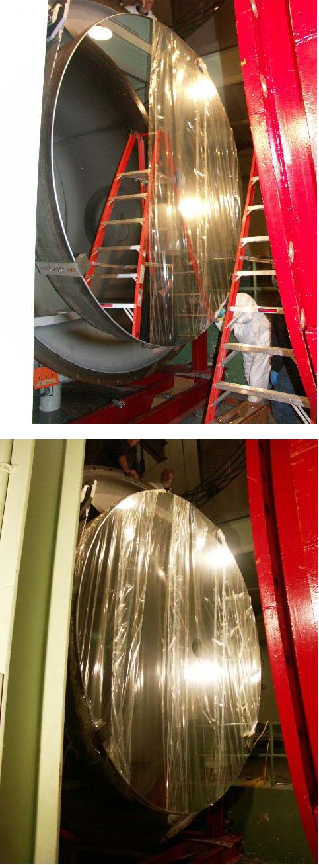 Then we put protective cellophane on.
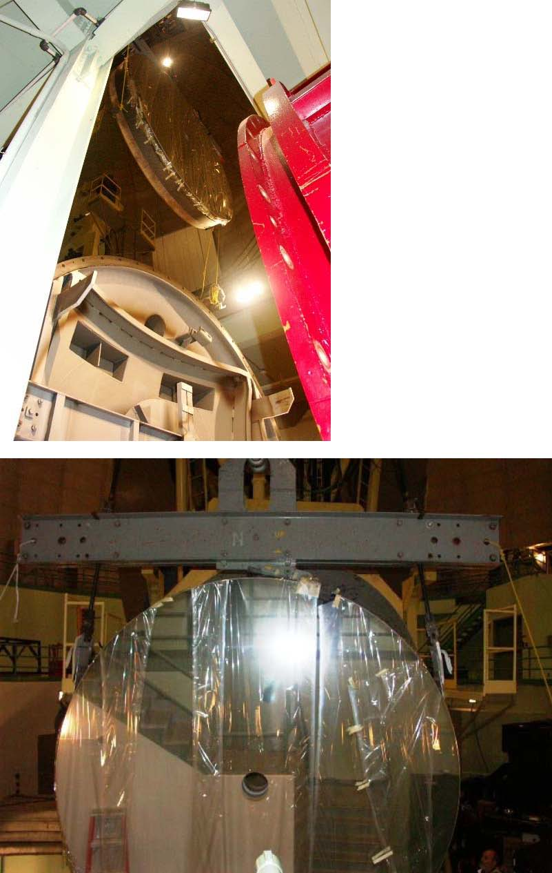 We then moved the mirror back to the platform.
Once there, we put a new skirt of foil around it. We changed the procedure slightly in that we used black duct tape in place of the beige masking tape in direct contact with the mirror. This was because it had been hard to get the old tape off and it was thought that the fiber backing of the duct tape would make it come off easier (we anticipate having to remove more tape residue with acetone).
We noticed when we put corrugated cardboard around it that the cardboard shed lots of fibers onto the surface of the pristine mirror. It was never blown off, to my knowledge. We recommend finding an equivalent material that is lint-free, like a foam strip, perhaps.
Darrell put the “top hat” back into the center hole of the mirror…he was supported by two people hanging on to his belt.
We left the mirror out in the open since there are known to be drips of grease that at times come off the telescope…however, it was moved under the telescope later that night anyway.
Day 4
On the last day of the process the mirror was bolted back onto the telescope.
Four heavy weights were bolted to the mirror. For some reason, the southernmost one was put on first, separately from the others.
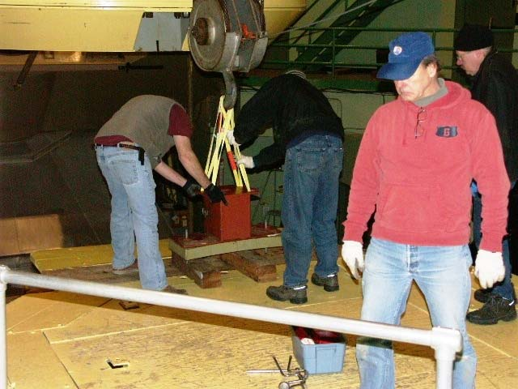
Later the other three were put on the platform. It was noted that the alignment marks for the weights had been painted over, so there was some pushing and pulling on the massive weights that was required to get them in to position. Next time the mirror comes out the positions of the weights should be re-marked before they are taken off. This will make replacing them much easier.
Then the “hub” of instruments was hoisted over to the platform and re-attached to the telescope.
Addendum 1 - Photos of the substrate of the mirror.
There were lots of floating debris and swirls of brown fluid beneath the surface.
Addendum 2 – Original surface of mirror
The ring near the center was blocked by the “top hat” that goes in the center hole.
Addendum 3 – New mirror surface
These six pictures were taken starting from standing at the NE position as the mirror sat on the platform and moving around it clockwise.

